**Lab 4**

id:7   
name: Harshil Patel

wiki: <https://github.com/Harshilpatel134/IOT/wiki/LAB-4>

[Document](https://github.com/Harshilpatel134/IOT/tree/master/LAB/Lab%204/Document)   
[Scource](https://github.com/Harshilpatel134/IOT/tree/master/LAB/Lab%204/Scource)   
[video](https://www.youtube.com/watch?v=crlGbYfrcuY)

**objective**

Lab 4 is divided into two parts

1. dialog flow system with NAO robot which will allow him to communicate with users.
2. connecting NAO robot to get temeprature data form temp. sensor which is connected with arduino.

**Approaches/Methods**

1. for part one we used speech recoganization and flow block of NAO raobot to create sequence of dialog.
2. user can ask NAO temerature of different city.it can then get the temerature details from API and will temp. details.
3. for part two we will upload temp. data to server(Thinkspeek) from temp sensor which is connected to arduino.
4. as NAO use inbuilt library we where not able to use https API calls in NAO robot to get data from server so we created a local server on our machine to first get data from thinkspeek and create a flask site using python which will be used by NAO robot to get temp. data.

**Member contribution**

all the team member work together to perform this lab.

**CKT diagram**

there is no CKT diagram for this lab.

**Part 1 layout**

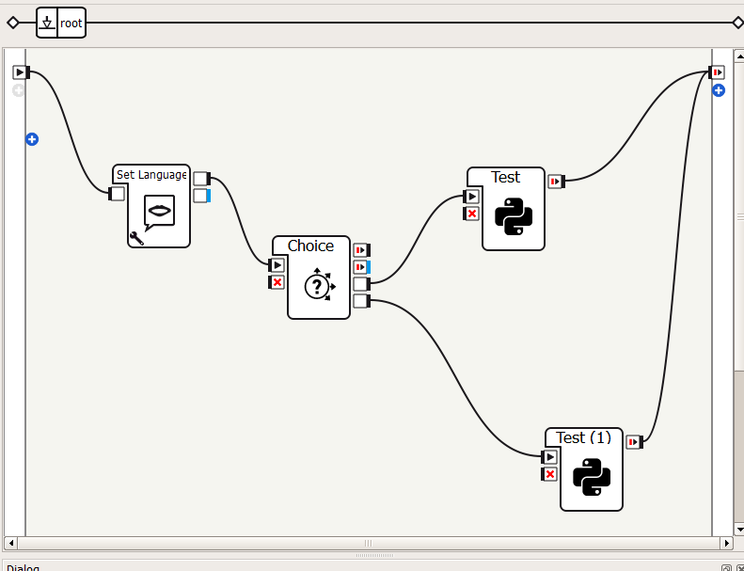

**Part 2 layout**

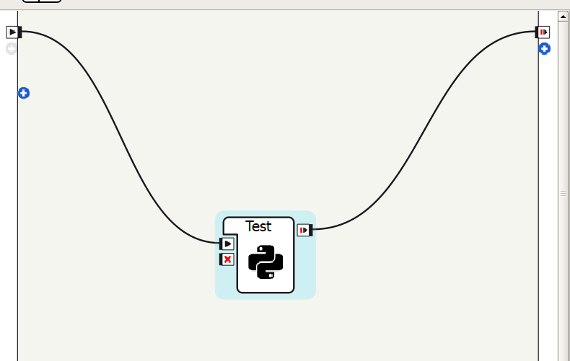

**Part 2 code**

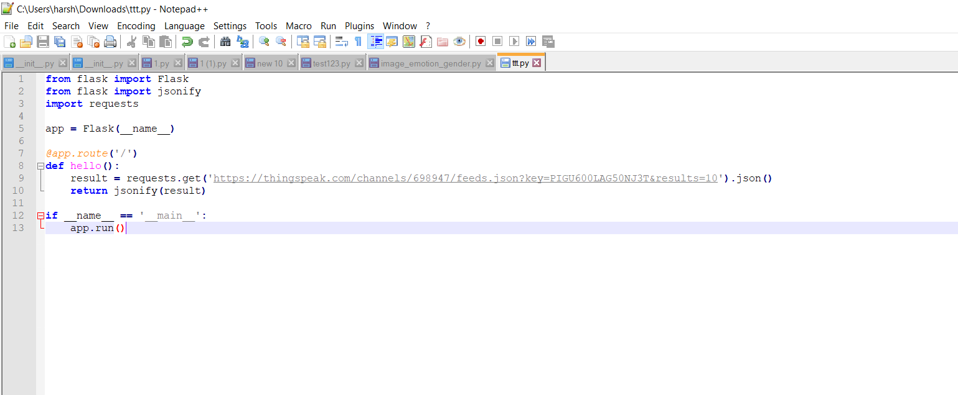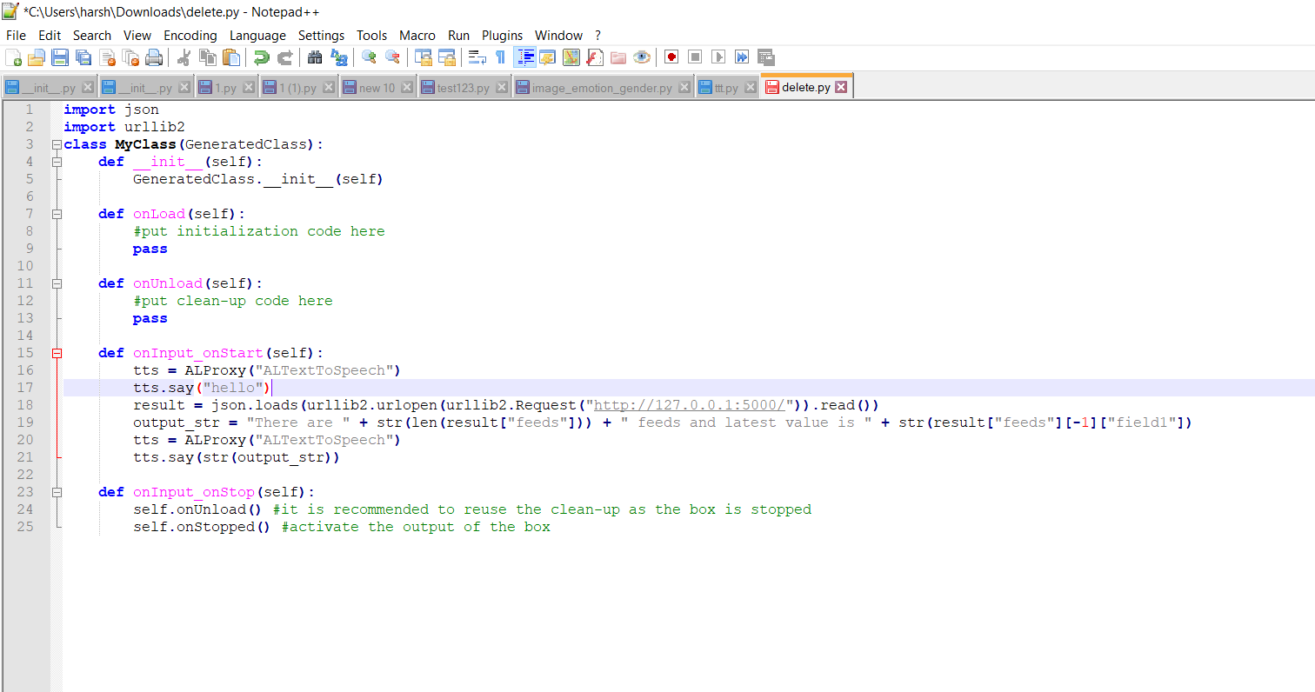

**data on server**

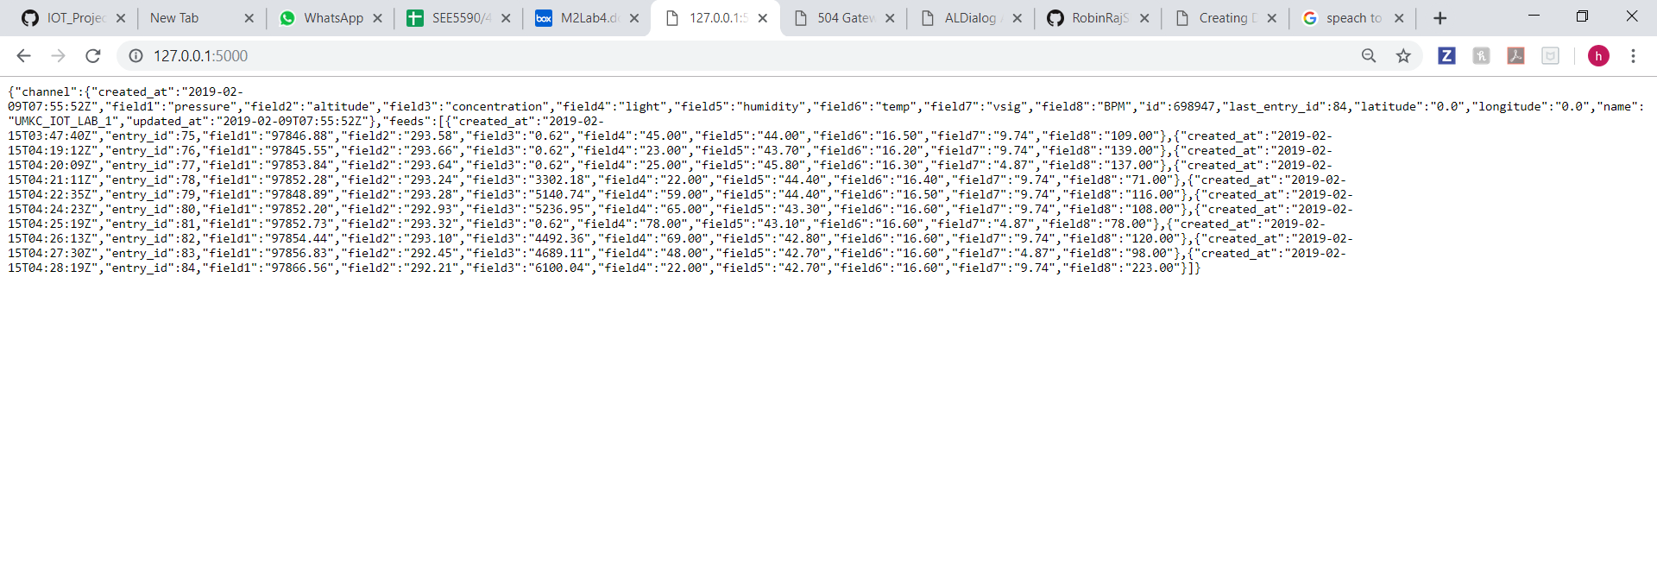

**conclusion**

with the help of this LAB we where able to learn...

1. dialog flow system with NAO robot which will allow him to communicate with users.
2. connecting NAO robot to get temeprature data form temp. sensor which is connected with arduino.